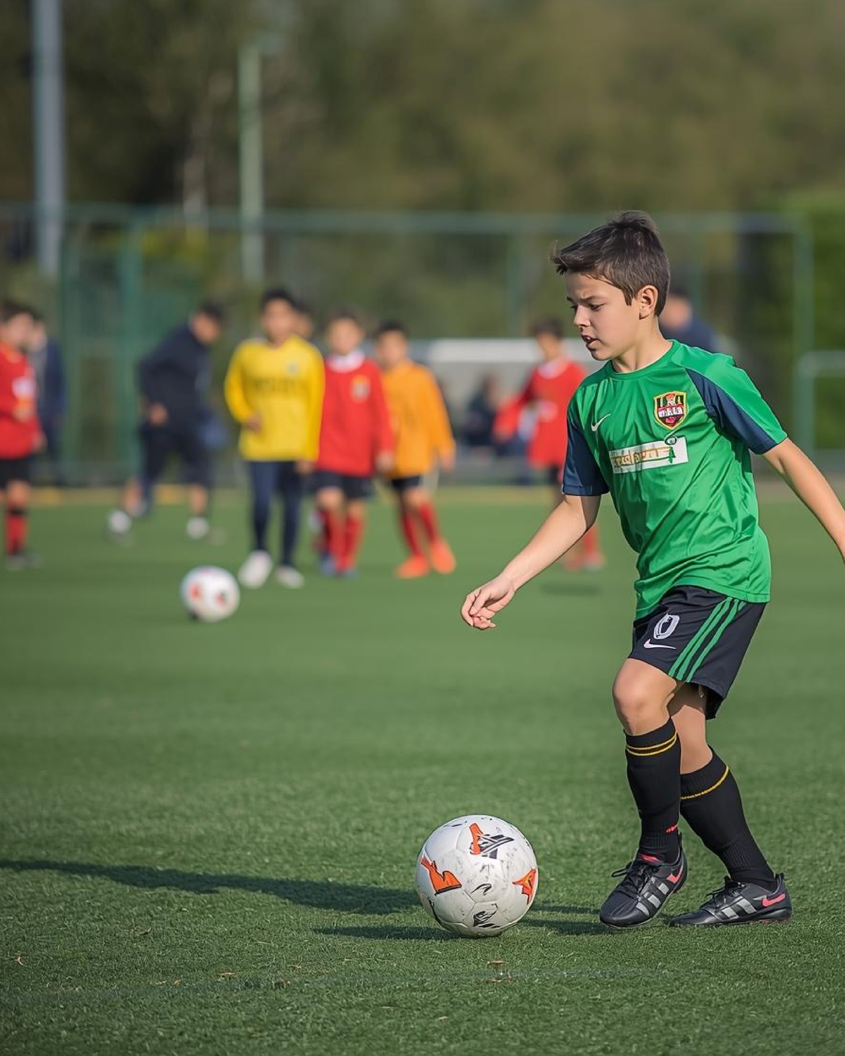

Book here:
Yeovil Town Football Coaching, Soccer School and After School Club
HOLIDAY
FOOTBALL
MONDAY 16
AND WEDNESDAY 18
FEBRUARY 2026

TH
TH
DATES
:
DATES:
FOR STUDENTS AT NORTH
CADBURY, COUNTESS GYTHA,
LOVINGTON, EVERCREECH,
ILCHESTER
NORTH CADBURY PRIMARY SCHOOL
Cary Road, North Cadbury,

Yeovil, Somerset, BA22 7DE

