Monday 28th September 2026
Dear Parents and Carers,

Dragon Class Trip – Wells Festival of Literature on Wednesday 21st October 2026.

Your child has the opportunity to attend the Wells Festival of Literature to hear the author, Helen Rutter, talk about her life, how she became an author and her new book Game Changers. This trip will be taken with the Dragon Class as part of your child’s English curriculum this term.

The event will take place on Wednesday 21st October at Cedars Hall, Wells. Children will depart after the register and be back at school for lunch. We are very grateful to Wells Festival of Literature for fully funding the transport and the event, meaning there is no cost to you as a parent, or the school. If you have any concerns about your child attending this trip, please let me know, or speak to Mrs Ruston.

During the morning there will be an opportunity to meet the author and to buy signed copies of Helen Rutter’s books. There will be five titles for the children to choose from including the author’s new book, The Game Changers. All the fiction books are available to buy at the much-reduced price of £2 (RRP £7.99). The Literature Festival are only able to sell books at these prices by significantly subsidising the cost, for which we are very grateful.

The book titles and a description of the stories can be found on the reverse of this letter. Please ensure your child has the money for any book purchases with them on the day in a secure purse or wallet. The Education Team at Wells Festival of Literature organise all the book sales and whilst they endeavour to have all the titles available on the day this may not always be possible. However, they are able to order more copies and deliver them to school within a few days. Please rest assured that there is no pressure to make a purchase.

If you have any queries please do not hesitate to let me know.

With best wishes,

Mrs Justine Ruston
Dragon Class Teacher
________________________________________________________________________________________________________________

Reply Slip – Dragon Class Trip to the Wells Festival of Literature on Wednesday 21st October 2026

Please return this slip by Friday 16th October.

Pupil’s Name ..................................................................................................................... …………

I give permission for my son/daughter to participate in the visit to the Wells Festival of Literature at Cedars Hall, Wells.

Signed: ........................................................................................ Dated: .......................................... (Parent/Guardian)

Emergency Contact No.: ....................................................................................................................
Helen Rutter Books for sale

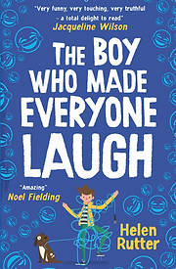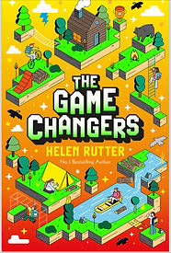

The Game Changers – an interactive book with multiple pathways, highly engaging format and a cracking mystery story, all in one.
The Boy Who Made Everyone Laugh – Billy Plimpton is an 11-year-old boy with a big dream. He wants to be a stand-up comedian. How will he find his voice, if his voice won’t let him speak?
The Boy with Big Decisions – Fred can’t make decisions about anything; you the reader will stand in Fred’s shoes and help him make decisions through the story. Will he brave enough to follow a different path?

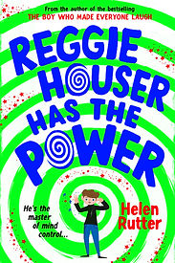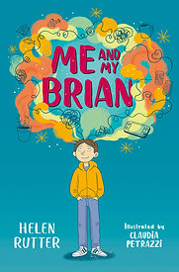

Reggie Houser Has The Power – Reggie has ADHD and struggles at school, he discovers that he has an incredible talent and must decide whether to use his incredible skills for good and trust his own brain.
Me And My Brian – With the help of his grandma, Josh finds a way to quieten his overactive ‘Brian’ in this gently humorous and empathetic tale about family life and mental health.

All books for sale at £2 ( RRP £7.99)

