
North Cadbury C of E Primary School
Curriculum Information
Spring Term
Class/Year Group: Dragon Class – Years 5 & 6
Dear Parents,
This letter is designed to provide key information about learning this term.

SUBJECT | CONTENT
English | Throughout this school term, we will be focusing on handwriting, spelling, punctuation and grammar whilst writing for a range of purposes. At the start of this term, we are going to be looking at our class test- The Butterfly Lion by Michael Morpurgo. We are going to turn the first chapter into a playscript, writing an information text on lions before creating a persuasive brochure to entice people to visit South Africa. We will then move onto creating poems and newspaper reports.
Maths | In Maths, we will begin the term with shapes, focusing on 2D and 3D and the properties and features they each have. We will then move onto measurement, statistics, and algebra. We will also continue to build on our arithmetic skills.
Science | In science this term, the children will learn about variation and adaptation. They will be able to explore how both Charles Darwin and Alfred Wallace separately developed their theories of evolution. They will examine the scientific evidence from  plants and animals (both living and fossilised) that has been gathered to support the theory of evolution.
Computing | This term we will continue to learn how to use technology safely, respectfully and responsibly. We will be using selection in programming to develop a quiz.
Geography | The first half of the term will cover our Geography topic, which involves looking closely at the continent of Africa. We will explore the physical features, different climates and biomes, the way people live across the continent and the different animals that live there. During the second half of this term, we will be looking at our significant figure- Nelson Mandela. We are going to be looking at the Apartheid, his life, and the changes he made to help the people of South Africa and what impact it has left behind.
History
R.E. | In Religious Education, we are going to be asking ‘What did Jesus teach about how to live?’ We will reflect on stories from the bible and discuss what key messages we can take from them. Later in the term we will learn about Good Friday and how Christians mark this day.
PSHE | This term, the children are going to be looking at ambitions and how to be the best versions of themselves before moving onto integrity and how to keep themselves safe.
D.T. & Art | To link in with our Topic, we are going to be looking at African landscape silhouette pictures. Children will have the opportunity to blend warm colours and use different brush strokes. Later in the term, we will create Nelson Mandela portraits.
P.E. | The children will continue to demonstrate the positive effects of exercise on both mental and physical well-being through their PE sessions with Mr Gilby. We will also continue to have weekly games sessions with Yeovil Town on a Wednesday at lunchtime.
M.F.L. | We will seek to improve our skills in French with an emphasis on grammar, listening, speaking, writing and developing cultural understanding. We will begin this term with a focus on days of the week and months of the year.
Homework

 | MATHS:  Children will receive Maths homework on a Friday to be handed in by the following Friday. Relevant Booster homework is set on a Monday to be handed in by the following Monday (Year 6 only).
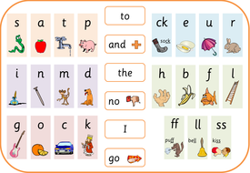 | ENGLISH:  Children will receive English homework on a Friday to be handed in by the following Friday. It will usually be a reading comprehension, and it is vitally important that children take their time and answer the questions to the fullness of their ability.
 | SPELLING:  Weekly spelling tests will be set every Friday and tested the following Friday. We will discuss the spellings and the rule they follow each week. The ‘Look, Cover, Write, Check’ is still the most effective method to help children learn their spellings.
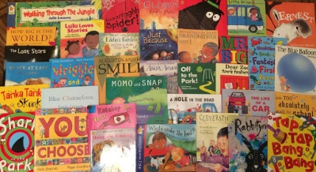 | READING:  Reading books should be brought to school and taken home every day. Children to record daily reading in homework diaries and parents to sign weekly as a minimum.

ADDITIONAL INFORMATION:
- PE – Wednesdays and Thursdays.
- Year 6 Booster club will take place after school on a Monday.

