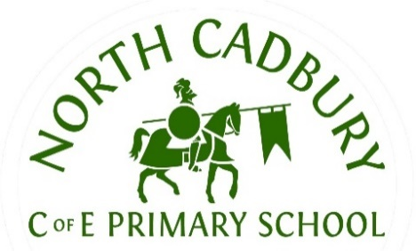
North Cadbury C of E Primary School
Curriculum Information
Spring Term.
Class/Year Group: Phoenix Class – Year 3 and 4
Dear Parents,
This letter is designed to provide key information about learning this term.
SUBJECT | CONTENT
English | This term, our English learning will be based around Stories from Around the World, allowing children to explore rich and exciting texts from different cultures and time periods. We will be reading and using The Egyptian Cinderella, The Hunt for the Golden Scarab and Escape from Pompeii, which link closely with our wider curriculum topics across the year. Through these texts, children will develop their understanding of grammar and sentence structure, while learning how to write for a range of different purposes and audiences.
Maths | In Maths, children will continue to build their understanding of multiplication and division, with a focus on times tables and formal written methods. They will then move on to a unit on measurement, where they will learn about area and perimeter through practical and problem-solving activities.
Science | In Science, children will study plants, learning to identify and describe the parts of plants and flowers through practical activities. They will explore what plants need to grow, investigate how water is transported, and learn about pollination, seed formation, dispersal and plant reproduction. Children will also plan and carry out a simple plant experiment, record their results, and review their learning at the end of the unit.
Computing | In Computing, children will be using iPads to explore stop-motion animation, learning how to create short animated sequences by taking and editing a series of images. This will help them develop their creativity, digital skills and understanding of how technology can be used to tell stories.
Geography | In Geography, learning will link closely to our History topic on Ancient Egypt. Children will develop their understanding of rivers by identifying their key features, locating major rivers around the world, and studying the route and importance of the River Nile. They will also explore how rivers are used by people and learn about the water cycle, helping them to understand the vital role rivers play in both the natural world and human life.
History | In History, children will study Ancient Egypt and explore where it fits in history by creating a timeline. They will learn about daily life, gods and goddesses, and Egyptian language and writing, as well as the significance of pyramids and mummification in Egyptian beliefs.
R.E. | In RE, children will focus on sacred texts, learning about the Bible and the Qur’an and the importance of these texts to Christians and Muslims. They will explore key stories and teachings before moving on to learn about Easter and its significance in the Christian faith.
Music | This term, the children will enjoy music lessons led by an external singing teacher, helping them learn and develop skills when playing the violin.
D.T. & Art | In DT and Art, children will develop their creativity through practical, hands-on activities supported by our Hygge sessions. They will explore historical art and design by creating pyramids and other pieces inspired by Ancient Egypt, allowing them to combine craft skills with an appreciation of history.
PE | Children will continue their weekly PE sessions with our in-school coach (Thursday) as well as the Yeovil Town Football Club coaches (Wednesday). We will also be completing our block of swimming sessions this term on a Friday afternoon.

Homework

 | MATHS:  One piece of Maths homework will go home on a Friday every other week reinforcing the work done in school during the week. This is to be returned on the following Friday, please. The children have also been provided with a login for TimesTables Rockstars. We encourage the children to access this as often as possible to practice their fluency.
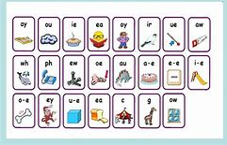 | ENGLISH:  One piece of English grammar homework will go home on a Friday every other week reinforcing the work done in school during the week. This is to be returned on the following Friday, please.
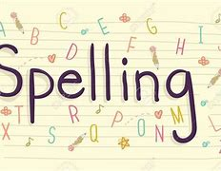 | SPELLING:  Spellings will be sent home each Thursday in an orange homework book and will be tested the following Thursday. This book is to be brought into school on a Thursday, please. As part of the spelling homework, we encourage children to learn their spellings by writing sentences in their spelling books.
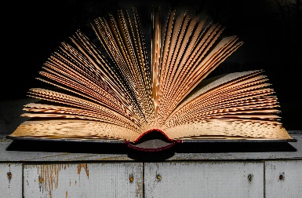 | READING:  To further support the children in developing their reading comprehension skills, one piece of reading homework will be sent home each week.  Regular reading at home is also encouraged. At least 4 times a week for 10 minutes to an adult, is preferred. We ask that reading records and reading books are in school every day.
ADDITIONAL INFORMATION:
- PE Kits – Wednesday and Thursday. Please ensure your child wears the appropriate school PE kit to school on these days. Leggings can be grey, black or navy, but must be plain.
- Snacks are not provided for KS2 please provide your child with a suitable snack each day. Ideally, fruit or a light savoury item.
- Please ensure your child comes to school every day with a water bottle.
Many thanks for your ongoing support,
Miss Shave and Miss Davies

