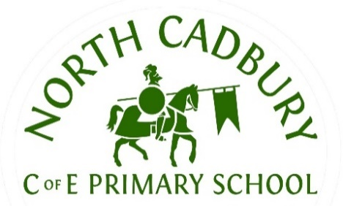
North Cadbury C of E Primary School
Curriculum Information
Spring Term.
Class/Year Group: Pixies – Reception
Dear Parents,
This letter is designed to provide key information about learning this term. This term, our topics are Traditional Tales and Out of this World. We will learn through play, stories, songs, and hands-on activities.
SUBJECT | CONTENT
Phonics | During Phonics lessons this term, we are introducing letter sounds through our phonics scheme, supporting children to hear initial sounds, blend simple worlds and develop confidence in early reading. We are moving onto phase 3 sounds this term, whilst revising previously learned phase 2 sounds and ensuring that children are confident in recognising letters and blending them to read simple words and phrases. Phase 3 sounds will introduce digraphs (two letters making one sound, such as sh, ch and th) and trigraphs (three letters making one sound, such as igh). Alongside learning new sounds, the children will practise segmenting words for writing and begin to read and spell simple phrases and sentences more confidently.
Literacy | In Literacy, we will be enjoying a range of stories, linked to our topics including The Three Billy Goats Gruff, Little Red Riding Hood, The Enormous Turnip, Whatever Next and How to Catch a Star. Children will begin to retell stories, mark-make with meaning and begin writing simple words, captions and progressing onto writing sentences too. Alongside story time, children will be encouraged to share their own ideas and create simple story maps. We will be continuing our letter formation and writing words, phrases and sentences, linked to our new sounds and using these within our writing.
Maths | This term in maths, we will be focusing on number including counting to 10, composition of numbers from 6-10 and representing numbers in different ways. After half term, the children will then move onto focusing on shapes and repeating patterns. Children will explore number, shapes and repeating patterns through songs, rhymes, and practical activities. The children will continue to develop their mathematical vocabulary including more, less, next, before, pattern, repeat and shape names.
Communication and language | When learning about communication and language, children will develop their speaking and listening skills through circle time activities, role play, and have opportunities to share their own experiences.
Personal, Social, and Emotional Development | In the topic of personal, social and emotional development, children will be building friendships, learning to share and take turns, talking about feelings and how to look after ourselves and others. This will be developed during play as well as PSHE lessons.
Physical Development | Children will strengthen their fine motor skills with cutting, threading and mark-making, and their gross motor skills through outdoor play, climbing, balancing and movement games.
Understanding the World | We will explore an understanding about the past and present, explore similarities and differences, ask questions and share ideas, explore the natural world around them and develop their curiosity skills too.
Expressive Arts and Design | During our topic of expressive arts and design, children will be developing their imaginative play, exploring sound and music, creating space inspired artwork and designing and building their own models too.
Computing | The children will learn to use simple technology safely, such as the interactive whiteboard, iPads and programmable toys e.g., BeeBots.
R.E. | Throughout this term, we will be understanding right and wrong this term which will include learning about kind and unkind behaviours, beginning to understand that actions have consequences and exploring how our choices can affect others. Towards the end of the term, we will also focus on the Easter story.
Music | This term, the children will sing songs, explore rhythm and beat with instruments, and listen to music linked to celebrations and stories.
P.E. | We will be negotiating space and obstacles safely in gymnastics and we will be developing our skills of balance and coordination.

Collective Worship takes place daily, either in the hall or as quiet reflection in our classroom.

Homework

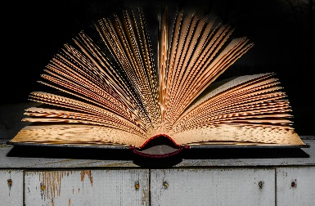 | READING:  Regular reading at home is encouraged. At least 4 times a week for 10 minutes to an adult is preferred. We ask that reading records and reading books are in school every day.  Children will be rewarded with a ticket for a half-termly prize draw, if they read at least 4 times a week, to an adult at home.

ADDITIONAL INFORMATION:
- PE Kits – Wednesday and Thursday. Please ensure your child wears the appropriate school PE kit to school on these days. Leggings can be grey, black or navy, but must be plain.
- Please ensure your child comes to school every day with a water bottle and a coat, thank you!
Many thanks for your ongoing support,
Miss Neville, Mrs Watson and Mrs Pett.

