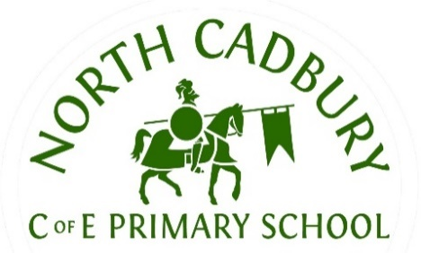
North Cadbury C of E Primary School
Curriculum Information
Spring Term.
Class/Year Group: Unicorn Class - Years 1 & 2
Dear Parents,
This letter is designed to provide key information about learning this term.
SUBJECT | CONTENT
English | During English lessons this term, we will be focusing on texts such as The Jolly Postman, Each Peach Pear Plum and Superworm and comparing them to other familiar texts. The children will be comparing stories and characters, writing their own modified story endings and writing for different purposes, in response to the text. We will explore a range of other text types including diaries, leaflets, instructional texts and poetry. The children will continue to consolidate their reading strategies and comprehension of a variety of texts and answer questions based on them. We will also continue to consolidate previous learning and broaden the children’s understanding and use of grammatical techniques and devices, including appropriate punctuation use, expanded noun phrasing and identifying word classes. We will work through the key spellings for your child’s age and their associated spelling patterns and rules. There will be a primary focus for Year 1, on securing the 40+ phonemes, in order to pass the phonics screening check.
Maths | In Maths, the children will be studying number and place value. Year 1 will focus on numbers to 20 and Year 2 will work with numbers to 100. We will be learning to add and subtract to 3 digits using both formal and informal written methods. They will also continue to consolidate their knowledge of fact families and the relationship between different operations. They will partition numbers and learn the related vocabulary: digit, tens, ones. Across both years, we encourage plenty of practice with counting, number bonds, and simple calculations to build fluency and confidence.
Science | This term in Science, the topic is Everyday Materials. In this topic, children will explore the materials that objects around them are made from and begin to understand why different materials are used for different purposes. They will also identify and name common everyday materials, such as wood, plastic, metal, glass, rubber, fabric and paper. Through scientific investigations they will discover why certain materials are suitable for specific objects, such as why glass is used for windows or plastic for toys.  Our seasonal study will be Winter followed by Spring and our Tree studies will be the fir tree and magnolia tree.
Computing | The children will learn to use technology safely, respectfully and responsibly; recognising the importance of personal data and the concept of data sharing.
Geography | Within our Geography topic, we will study The Continents and Oceans of the World. The children will name and locate the seven continents of the world. Name and identify the five oceans. Use maps, globes and atlases to explore where continents and oceans are found. Understand that the world is made up of land and water. Compare where they live with places in other parts of the world. Use simple geographical language, such as continent, ocean, map and globe. Through practical activities, songs, stories and map work, children will build their location knowledge and begin to understand how places around the world are connected.
History | As part of our History module, we will study The History of Transport. Children will learn about how transport has changed over time. They will explore different types of transport used in the past and present, such as cars, trains, boats and planes. They will learn to use simple historical language like old, new, past and present, place events in time order, and understand how changes in transport have affected everyday life. Through stories, pictures and hands-on activities, children will develop an early understanding of change over time.
R.E./ PSHE | In PSHE, children will learn about setting goals, believing in themselves and trying their best. They will explore what it means to have ambition, understanding that this involves having goals, working hard and not giving up when things feel challenging. They will recognise their strengths and interests. Understand the importance of trying their best and developing a positive attitude. Learn that mistakes help us to learn and improve. Set simple goals and talk about ways to achieve them. Show perseverance and resilience when learning new skills. Through discussion, stories and activities, children will develop confidence, self-belief and a growth mindset, helping them to become motivated learners who always aim to be the best they can be.  RE: After half term the children will learn about the Christian story of Easter and why it is an important festival for Christians. Children will learn to: listen to and retell key parts of the Easter story, including Palm Sunday, the Last Supper, Good Friday and Easter Sunday. Understand that Easter is about love, sacrifice and new life. Talk about why Easter is important to Christians. Share their own thoughts and feelings about the messages in the story. Through stories, discussions, art and role play, children will develop respect for religious beliefs and begin to understand how faith influences people’s lives.
Music | This term, the children will continue to learn about the value of musical notes and their given names. They will explore how these are then represented through beat and rhythm.
D.T. & Art | We will be creating seasonal observational paintings and crafts. We will build a moving vehicle. We will also be busy baking in the kitchen.
P.E. | This term the children will enjoy gymnastics. Learning to move purposefully and safely using floor routine and large equipment.

Collective Worship takes place daily, either in the hall or as quiet reflection in our classroom.

Homework

 | MATHS:  One piece of Maths homework will go home on a Friday reinforcing the work done in school during the week. This is to be returned on the following Friday, please.
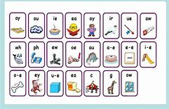 | ENGLISH:  As part of the spelling homework, we encourage children to learn their spellings by writing sentences in their spelling books. This also helps to reinforce the definition of the word.
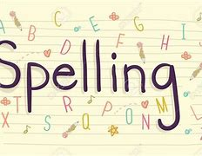 | SPELLING:  Spellings will be sent home each Friday and will be tested the following Friday. There will be a variety of spellings related to strategies being taught.
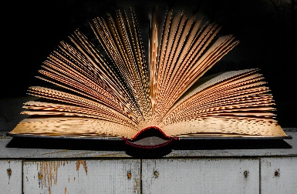 | READING:  Regular reading at home is encouraged. At least 4 times a week for 10 minutes to an adult, is preferred. We ask that reading records and reading books are in school every day.  Children will be rewarded with a ticket for a half-termly prize draw, if they read at least 4 times a week, to an adult at home.

ADDITIONAL INFORMATION:
- PE Kits – Wednesday and Thursday. Please ensure your child wears the appropriate school PE kit to school on these days. Leggings can be grey, black or navy, but must be plain.
- Snacks are provided for KS1 children. However, we often find the children require a little extra, especially in the cooler months, so please do feel free to provide a suitable snack each day, should your child require it. Ideally, fruit or a light savoury item.
- Please ensure your child comes to school every day with a water bottle.
Many thanks for your ongoing support,
Mrs Stroud and Mrs Hawker

